Instant noodle queen building Africa’s future with food revolution

**SHE’S the Zambian entrepreneur who could finally make Africa a global power player, by harnessing the surprising power of instant noodles.**

**EMMA REYNOLDS**

[news.com.au](https://www.news.com.au/)JUNE 10, 2015**10:08AM**



Monica Musonda thinks instant noodles could be revolutionary.*Source:Supplied*

INSTANT noodles are a staple part of many young people’s diets.

But, until recently, Africa was a step behind much of the world, with only a few imported brands available.

Zambian entrepreneur Monica Musonda saw an opportunity to change the fortunes of her country using the humble snack.

Africa spends $36 billion a year on importing food, yet it has [60 per cent of the world’s uncultivated arable land](http://www.howwemadeitinafrica.com/four-things-you-should-know-about-agriculture-and-food-in-africa/40675/), according to the World Bank. Musonda noticed that wheat was only used to make bread, and some biscuits, with much of the country’s large crop exported.

She quit her job as a lawyer and started Java Foods, aiming to provide affordable nutrition to Africa.

“Agriculture’s where the potential is,” she told the World Economic Forum Africa Summit in Cape Town last week. Her eeZee Instant Noodles are now Zambia’s biggest-selling brand and growing in popularity across the continent.

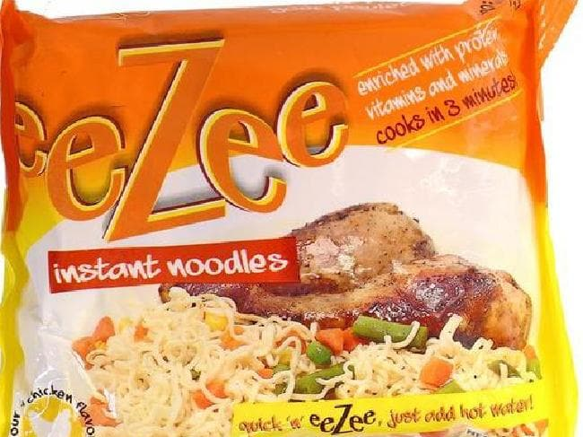

Musonda’s company’s first product, eeZee noodles.*Source:Supplied*

The noodles sell for just two kwacha ($0.00037), offering young people an affordable and convenient meal.

It’s a move that would delight the [Japanese inventor of instant noodles, Momofuku Ando](http://www.news.com.au/national/grand-funeral-planned-for-noodle-king/story-e6frfkp9-1111113050683), who created the product in the hope of ending world hunger.

Ando, who died in 2007, came up with the idea in the years after World War II, when food shortages plagued Japan. In his biography, he said he was inspired when he saw a long line of people in war-ravaged Osaka waiting to buy steaming noodles at a black market stall. “Peace prevails when food suffices,” he said.

He created the perfect tasty, non-perishable, economical and safe post-war food option, later turning to the problem of creating space noodles for astronauts. [Japanese people recently voted noodles one of their best exports](http://news.bbc.co.uk/2/hi/asia-pacific/1067506.stm).

Musonda decided to follow his lead to develop Africa’s economy after she moved to Nigeria to work for a law firm in 2008. “[What inspired me the most about Nigeria](http://www.howwemadeitinafrica.com/what-zambian-entrepreneur-monica-musonda-learnt-from-aliko-dangote/28574/) was the entrepreneurial spirit — the fact that so many young people are taking the leap and working for themselves,” she told*How We Made It In Africa*. “They are not afraid to risk everything for what they believe in. I had been going back and forth to Zambia and one thing I noticed was that the economy was still dominated by foreign companies despite the opening up of the market.”

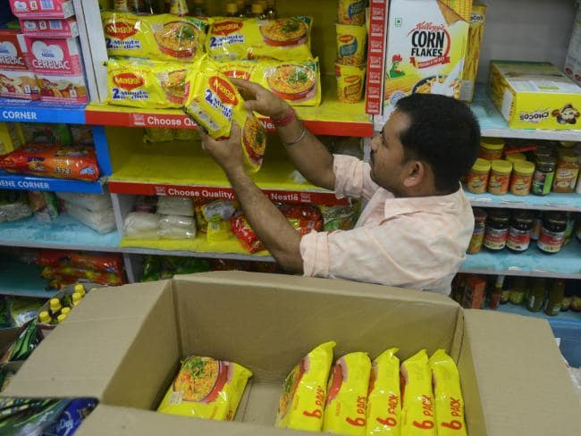

Nestle’s Maggi instant noodles were this week removed from the shelves in India and East Africa after a food scare.*Source:AFP*

Maggi 2 Minute Noodles have been the most popular brand among southern Africa’s poorer communities, students and office workers. But the [Nestle noodles were this week removed from shelves](http://www.bbc.com/news/world-africa-33053683) in shops in East Africa and India, after tests showed the snack contained unsafe levels of lead.

Musonda’s noodles offer the opportunity to feed Africa’s youth, bolster the country’s economy through agriculture, and provide jobs.

“As the continent starts to look at healthier and more nutritional food options that exist in the market, and when they are offered real consumer choice at a price point that is genuinely affordable, then their eating habits will get better and they will get healthier,” she told the *Lioness of Africa*blog. “It is a long-term view but I would really like people to see that [Java Foods is about providing healthy, affordable nutrition](http://www.lionessesofafrica.com/blog/2014/11/26/monica-musonda-the-startup-story-of-a-tenacious-food-manufacturer-that-is-looking-to-bring-better-nutrition-to-zambia).”

Her company is also producing pasta and has identified its next product line: fortified breakfast cereals, with [porridge production from local grains slated to start next year](http://qz.com/422002/do-african-countries-need-instant-noodles-to-build-their-middle-class/), *Quartz*reported*.*

Perhaps you can build a country on instant noodles.